Senior Design 1 Project Design V2

February 12th, 2021

Pin Transfer Robot for Chemical Screening

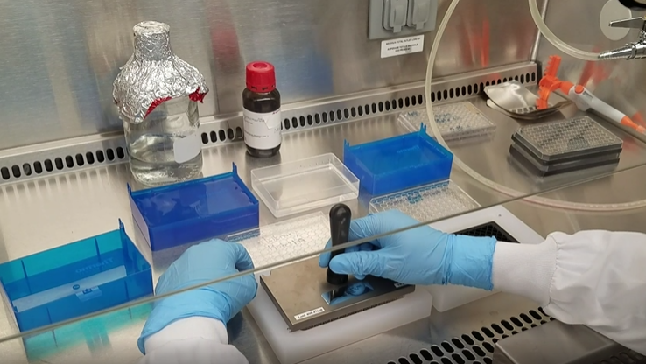

Department of Electrical Engineering and Computer Science

University of Central Florida  
Dr. Samuel Richie

Group H

Christopher Clifford Electrical Engineering

Brenden Morton Computer Engineering

Dominic Simon Computer Engineering

Yousef Abdelsalam Computer Engineering

**Project Narrative**

As an engineering student working in a regenerative medicine laboratory for the past two summers, I’d thought of many ways to optimize experiments by inventing tools that could automate or assist with parts of the experimental process. Much of my research involved testing an assortment of small molecules and growth factors on differentiating stem cells to determine their influence on the cell’s protein expression. This process was normally done by me manually and it is very tedious and any small error or inconsistency can have a massive influence on the outcome and the repeatability of my experiment. For this reason, I became interested in resting a robot that could carry out the chemical screening process for me so that there would be drastically less inconsistencies and time in my experiments. There are currently robots that do what I am describing but as you will see, they will cost anywhere from tens of thousands to millions of dollars. Some labs are completely dedicated to screening chemicals for toxicity and safety, or to find potential anti-cancer drugs. My goal with this project is to create a small robot that could be used by biology labs whose primary focus is not chemical screening and comprises a small part of what the lab does. The benefit of this is it would increase possibilities for experiments in these labs while not having a monetary barrier to entry. I myself would use a robot like this to conduct my experiments in the future and I can personally say that it would greatly increase my productivity. With this robot I could expect orders of magnitude more discoveries based on the quantity of experiments I could conduct.

Some alternatives to our project in the marketplace currently include full scale lab implementation, liquid handling robot adapted to handle both automatic and manual pin transfer. Full scale lab implementation takes up an entire building with incubation chambers, imagers and robotics. The entire chemical treatment, cell culture, and imaging process is automated. For reference, I have included two videos of a full scale lab implementation, one from the [Environmental Protection Agency](https://www.youtube.com/watch?v=T4K-YrqtwZA) and another from the [Broad Institute](https://youtu.be/S1V5q_6U6oM). The first real possibility for a smaller lab that wants to get started in chemical screening would be purchasing an adapter for a liquid handling robot. Liquid handling robots are used to dispense and sample liquids from wells or microplates. Some companies such as V&P Scientific sell adapters that can be mounted to the head of liquid handling robots so that a pin transfer tool can be fitted to the robot. This effectively creates a pin transfer robot with some major drawbacks. The biggest problem is that liquid handling robots are designed to only handle one plate a time, which means that if you would like to treat duplicate plates or many different cell plates, then you would need to manually move the plates in and out of the workspace after each program execution. Ideally, our project will handle plate management by placing the plate in and out of the work space. This would strongly differentiate our project from available options on the market today.

**Design Considerations**

In the field, smaller research labs tend to have to use some form of pipetting/pin-transferring tool that needs to be properly handled and operated. As stated before, not only can this process be tedious, but it also entails room for human error and cross-contamination. In order to alleviate this, we will attach a pin transfer tool to a robot in such a way so as to automate the pin transfer operation. There would also be a drying fan that would be activated after the pin transfer operation completes. There must also be a mechanism for aligning the pin transfer head with the 96/384 well plate, which must involve the head moving up and down for the pin transfer motion in the least. Ideally, there would also be a mechanism for moving the plates into position from an existing stack or repository of plates.

There are many such possible implementations that do just that. One of the more reasonable and practical implementations is represented in the sketches below shown below:

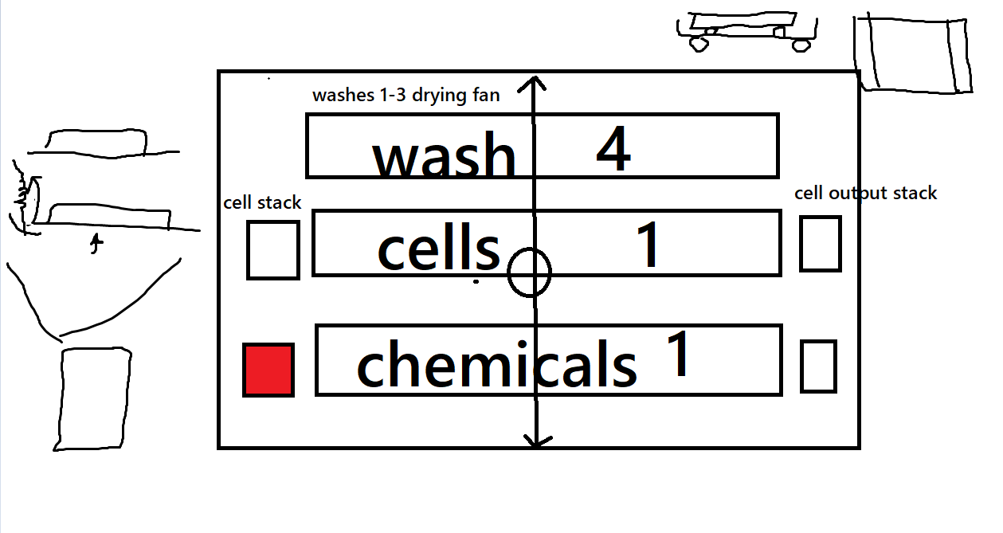

**Figure 1: Rough Illustration of Design Idea 1**

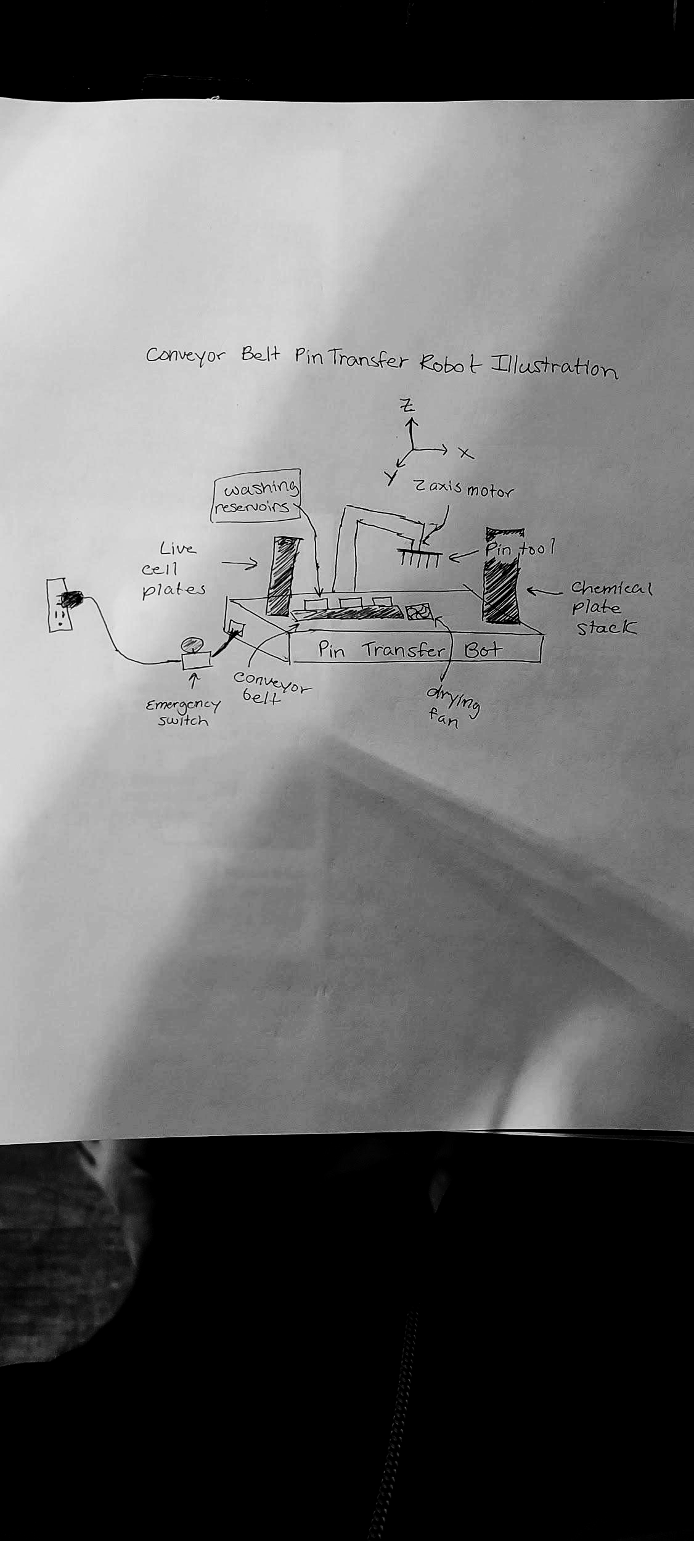

**Figure 2: Rough Illustration of Design Idea 2**

As you can see, there should be two FIFO structures on the left as per Figure 1, labelled as the white and red squares. There should be a gantry head that has two degrees of freedom, namely the y and z axes. An example of the 2-axis gantry can be seen in Figure 2. There is no need for a third degree of freedom here since the wash steps, cell plates,and the chemical plates are all moved through their own separate conveyor belts into the appropriate position. When the cell and chemical plates are in the appropriate position, the head must drop onto the chemicals and use the pin tool to transfer the chemicals to the cells. Once the pin transfer has succeeded, the pin tool must move to the wash belt in order to be washed in a step by step process. Possible wash steps include combining a cleaning chemical agent with a drying fan or suction. From there, the cell and chemical plates will move to an output stack.

Lastly, there is the possibility of using a gantry robot that can move anywhere within the XYZ coordinate plane provided for it in order to perform the pin transfer operation on well plates that are provided within a grid-like area.

Some nice-to-have ideas that could be implemented would be some kind of barcode scanner that can read information about the time in which the pin transfer operation was implemented along with the cells and chemicals that were used to be read into a database.This is mostly because the FIFO structures that we plan on using are not going to be sorting the plates in any way, and so implementing barcodes would allow researchers to identify the plates and know what reactions took place so that they may document the results of the reaction as needed. Reference the block diagram (Figure 3 and Figure 4 for more details).

**Requirements and Specifications**

* Robot should be plug and play. Configure number of plates and washing steps and then the cycle can begin without interaction with a lab technician until completion of the task.
* GUI supported by a 16x4 LCD screen
  + Asks for Number of Well Plates
  + Allows the user to tell how deep to put the pins in the solution
  + Allows the user to tell how long to leave the pins in the solution
  + Alerts the User when the pin transfer is complete
* 120V PSU
* Should be able to be plugged into standard US plugs and should only run when plugged in to an outlet
* Standard Pin Transfer Tool
* Should be able to handle a maximum of (16) Perkin Elmer 96 well plates and a minimum of 8. Extending to 384 well plates should also be a reasonable stretch goal.
* At most 48 inches in width and 18 inches in length
* 200 ml refillable solution reservoir
* Up to three wash steps to perform on the pin tool
* Able to be sterilized using 70% ethanol to be in a biosafety cabinet.
* Total cost should be less than $1000

**Block Diagrams**

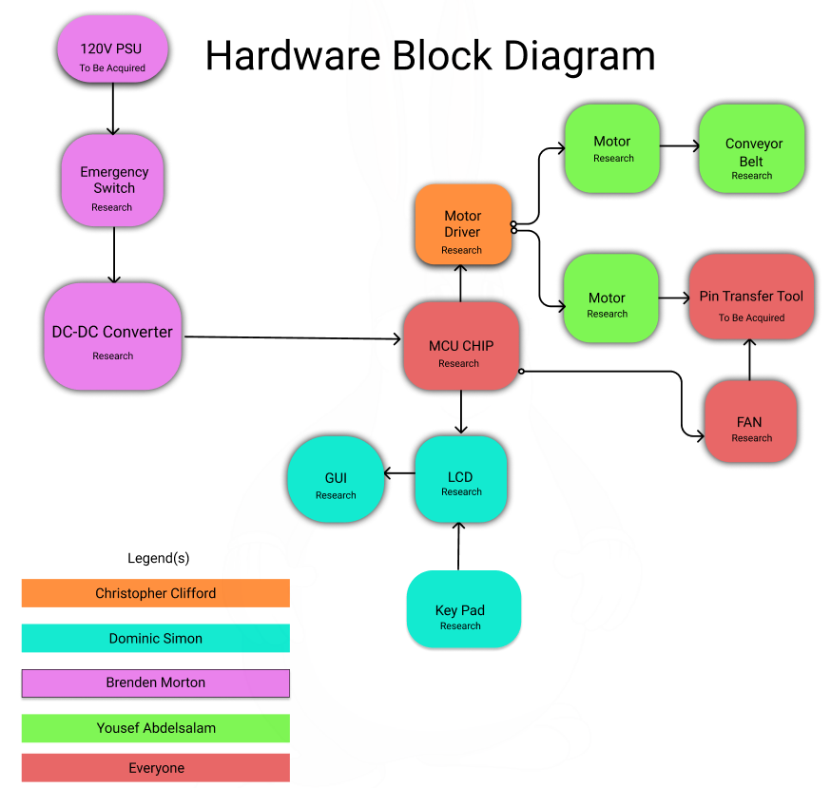

**Figure 3: Hardware Block Diagram**

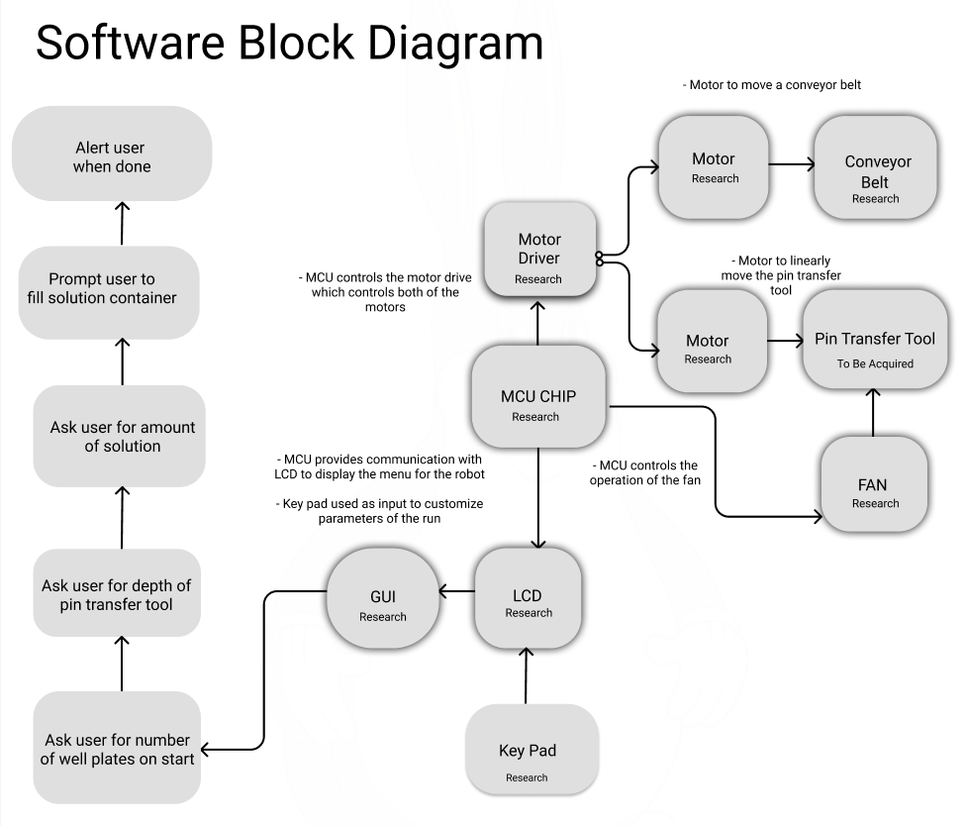

**Figure 4: Software Block Diagram**

**Estimated Budgeting and Finance**

Though it is anticipated that there would be a number of moving parts to this project that would be decided on at later stages of the design phase of SD1, one can expect that

|  |  |  |  |  |
| --- | --- | --- | --- | --- |
| Part | Description | Quantity | Unit Cost | Total Cost |
| xxx-xxxx | Pin Transfer tool | 1 | $0 - $200 | $0 - $200 |
| Arduino Atmega 2560 | MCU | 1 | $0 - $20 | $0 - $20 |
| xxx-xxxx | Conveyor Belts | 1 | In research of part | In research of part |
| xxx-xxxx | 12V Fan | 1 | In research of part | In research of part |
| Youngneer | 12V Relay (8 pc) | 1 | $11.99 | $11.99 |
| xxx-xxxx | Power Supply Unit | 1 | ~$100 | ~$100 |
| xxx-xxxx | DC-DC Converter | 1 | Design Stage | Design Stage |
| xxx-xxxx | PCB | 5 | Design Stage | Design Stage |
| xxx-xxxx | Power Switch | 1 | Design Stage | Design Stage |
| BIQU A4988 | Motor Driver | 2 | $9.50 | $19.00 |
| Usongshine 17HS4401S | Motor | 2 | $9.97 | $19.94 |
| Any LCD | LCD (16x4) | 1 | ~$15 | ~$15 |
| COM-14662 | Key pad | 1 | $4.50 | $4.50 |

**Table 1: Cost per Item**

|  |  |
| --- | --- |
| Number of Team Members | 4 |
| Sponsor Contribution | Unknown |
| Total Cost of Project Based on Current Prices | ~$400 |
| Contribution per team member | ~$100 |

**Table 2: Cost per Member**

**Decision Matrix**

|  |  |  |  |  |  |  |  |
| --- | --- | --- | --- | --- | --- | --- | --- |
| Ideas/  Nice-to-haves | Difficulty(higher is easier) | Time  (higher is less time) | Space  (higher is less space) | Quality | Practicality | Cost  (higher is cheaper) | Totals |
| 3 Axis Gantry Robot | 6.0 | 6.5 | 6.0 | 8.5 | 7.5 | 6.0 | 40.5 |
| Double axis Conveyor belt Robot | 7.5 | 7.5 | 6.5 | 8.5 | 6.5 | 7.0 | 43.5 |
| Refrigerator Component | 5.0 | 5.0 | 3.5 | 8.0 | 4.0 | 4.0 | 29.5 |
| Barcode Reader | 9.0 | 8.0 | 8.0 | 5.0 | 7.0 | 9.5 | 46.5 |
| Requiring stack to take from | 3.0 | 3.0 | 8.0 | 9.0 | 9.0 | 6.0 | 38.0 |
| Requiring stack to put on | 3.0 | 3.0 | 8.0 | 9.0 | 9.0 | 6.0 | 38.0 |
| Cleaning solution quantity detector | 9.0 | 7.5 | 7.0 | 2.0 | 4.5 | 8.0 | 38.0 |

**Table 3: Decision Matrix**

**House of Quality**

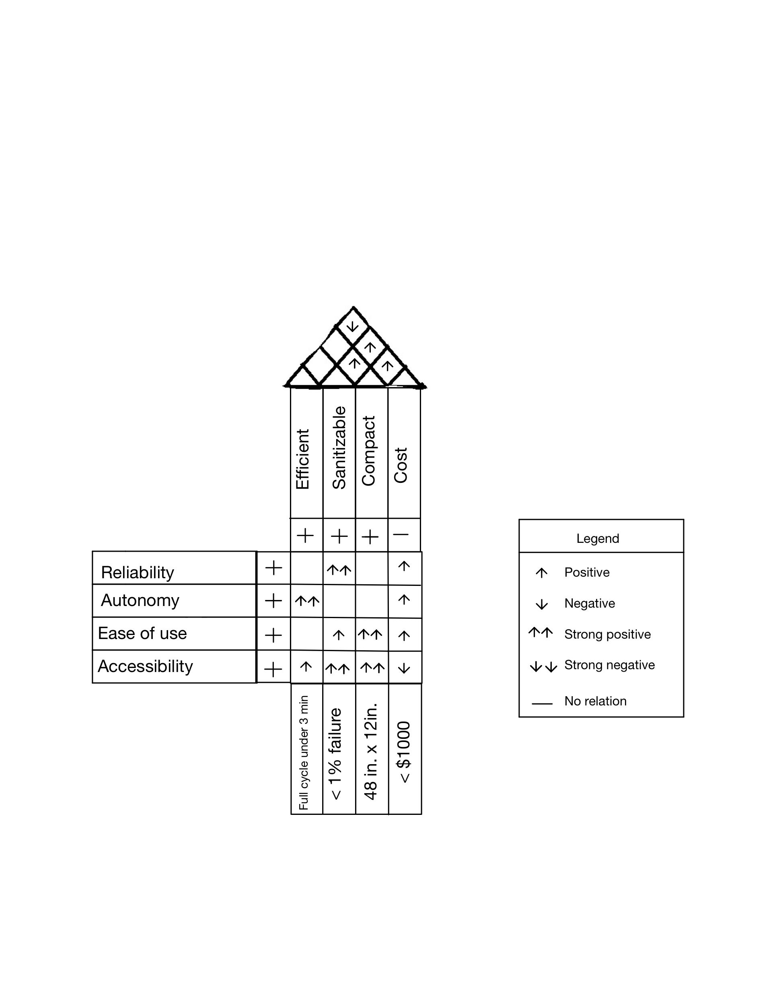

**Figure 5: House of Quality**

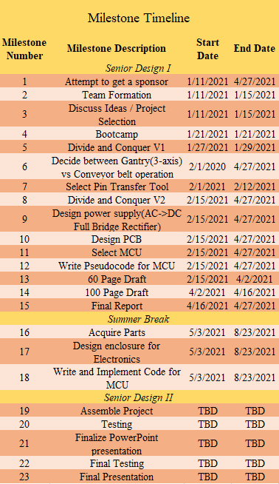

**Figure 6: Milestone Timeline**